**KOLEGJI UNIVERSUM**



Programi Shkenca Kompjuterike / Viti I / Semestri 2

Lënda: Hyrje ne Struktura te te Dhenave

Chapter 6 – Fundamentals of Computer Programming with C#

Studentja: Prof.Dr:

Elsira Kabashi Muzafer Shala

Asistenti: Laberion Zebica

Prishtinë 2021

1. Write a program that prints on the console the numbers from 1 to N.  
   The number N should be read from the standard input.

using System;

namespace Detyra1

{

class Program

{

static void Main(string[] args)

{

Console.Write("Enter first number: ");

int length = Int32.Parse(Console.ReadLine());

for (int i = 1; i < length; i++)

Console.WriteLine(i);

}

}

}

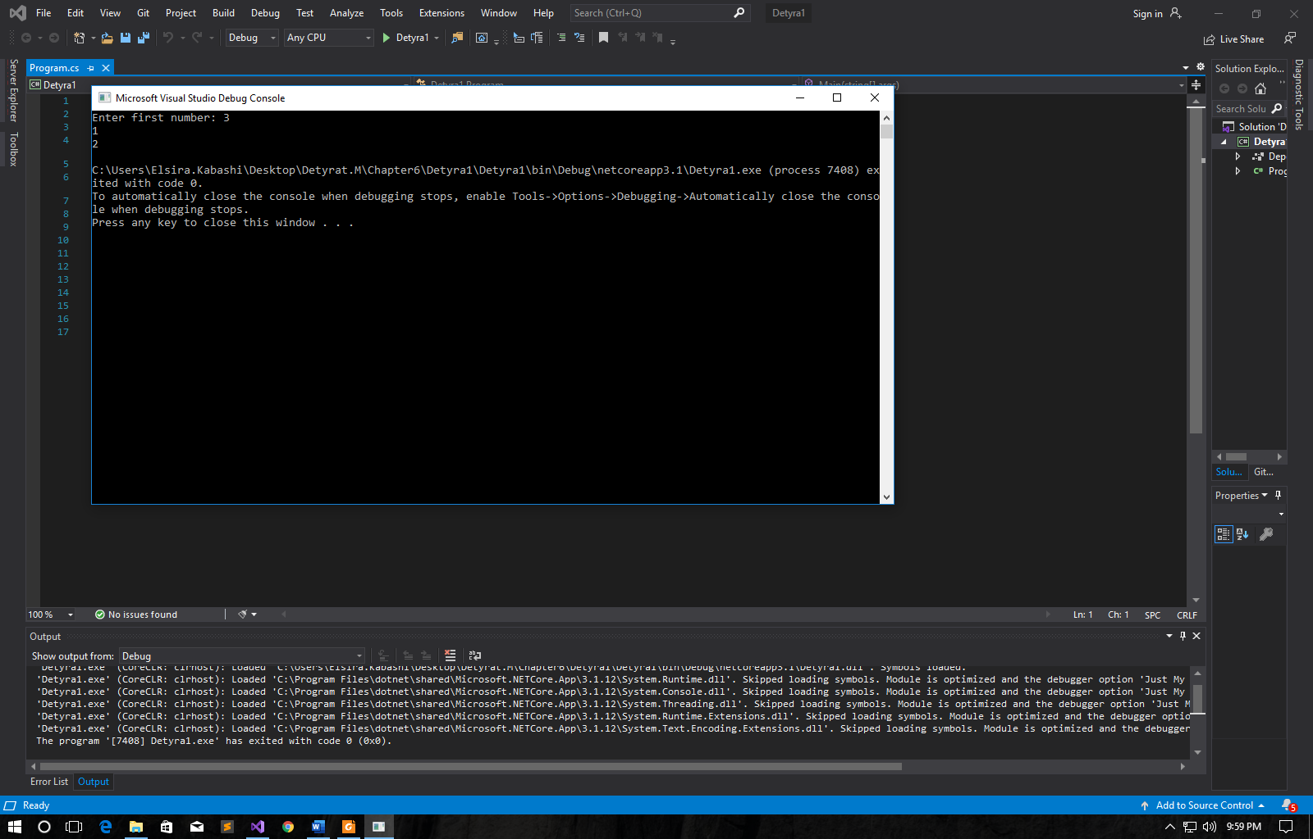

2. Write a program that prints on the console the numbers from 1 to N,  
which are not divisible by 3 and 7 simultaneously. The number N  
should be read from the standard input.

using System;

namespace Detyra2

{

class Program

{

static void Main(string[] args)

{

Console.Write("Enter N: ");

int length = Int32.Parse(Console.ReadLine());

for (int i = 1; i < length; i++)

{

if (i % (3 * 7) != 0) Console.WriteLine(i);

}

}

}

}

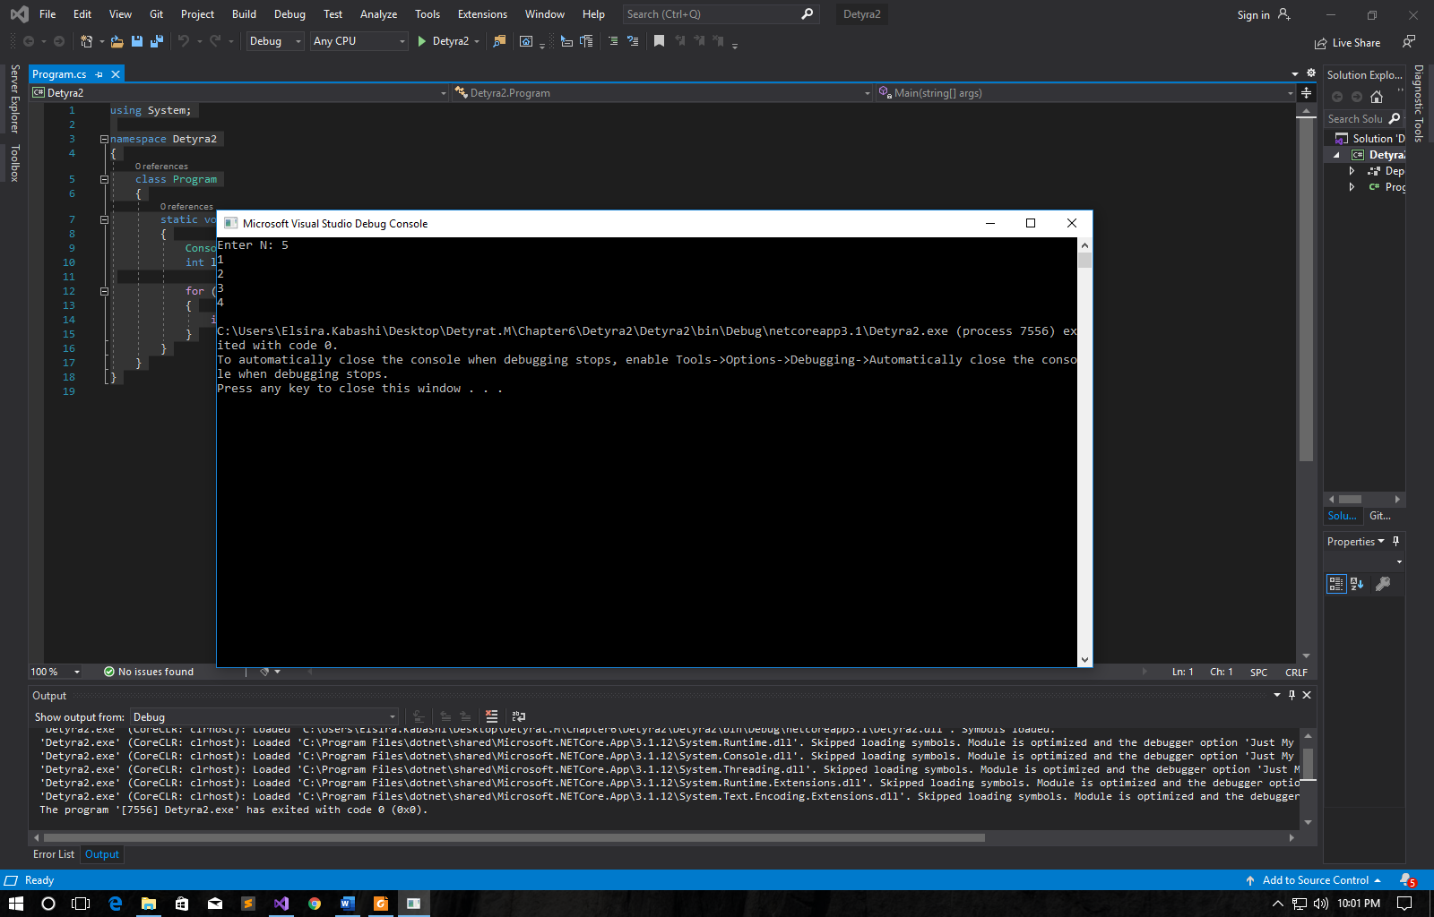

3. Write a program that reads from the console a series of integers and  
prints the smallest and largest of them.

using System;

namespace Detyra3

{

class Program

{

static void Main(string[] args)

{

int lowest = 0, highest = 0, input;

Console.Write("Enter numbers length: ");

int lenght = Int32.Parse(Console.ReadLine());

for (int i = 0; i < lenght; i++)

{

Console.Write("Enter number: ");

input = Int32.Parse(Console.ReadLine());

if (i == 0) lowest = highest = input;

else

{

if (lowest > input) lowest = input;

if (highest < input) highest = input;

}

}

Console.WriteLine("Lowest - {0}, Highest - {1}", lowest, highest);

}

}

}

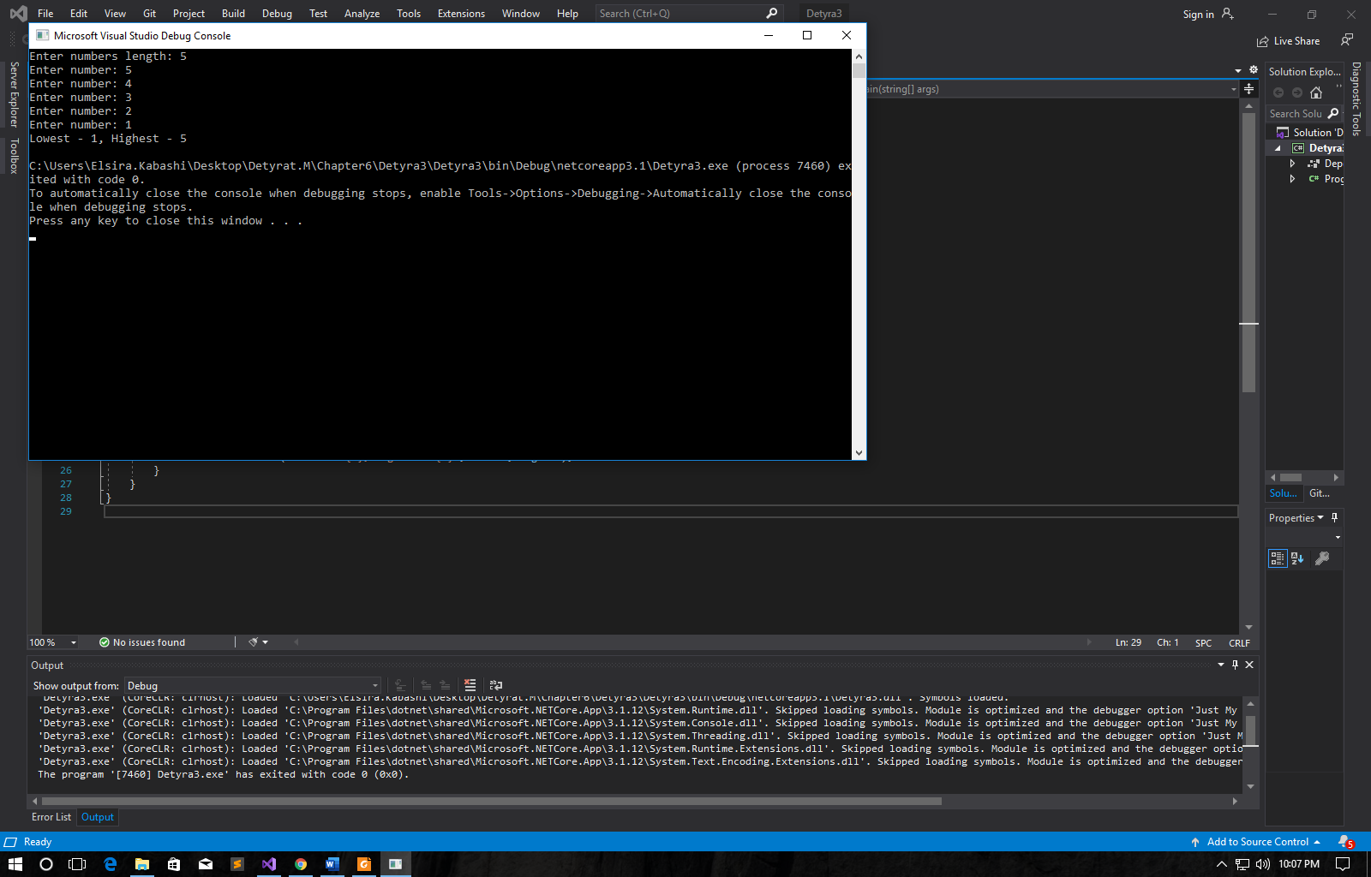

4. Write a program that prints all possible cards from a standard deckof cards, without jokers (there are 52 cards: 4 suits of 13 cards).

using System;

namespace Detyra4

{

class Program

{

static void Main(string[] args)

{

for (int i = 0; i < 4; i++)

{

if (i != 0) Console.WriteLine();

for (int j = 0; j < 13; j++)

{

switch (i)

{

case 0: Console.Write("Hearts "); break;

case 1: Console.Write("Diamonds "); break;

case 2: Console.Write("Spades "); break;

case 3: Console.Write("Clubs "); break;

}

switch (j)

{

case 0: Console.WriteLine("2"); break;

case 1: Console.WriteLine("3"); break;

case 2: Console.WriteLine("4"); break;

case 3: Console.WriteLine("5"); break;

case 4: Console.WriteLine("6"); break;

case 5: Console.WriteLine("7"); break;

case 6: Console.WriteLine("8"); break;

case 7: Console.WriteLine("9"); break;

case 8: Console.WriteLine("10"); break;

case 9: Console.WriteLine("J"); break;

case 10: Console.WriteLine("Q"); break;

case 11: Console.WriteLine("K"); break;

case 12: Console.WriteLine("A"); break;

}

}

}

Console.ReadLine();

}

}

}

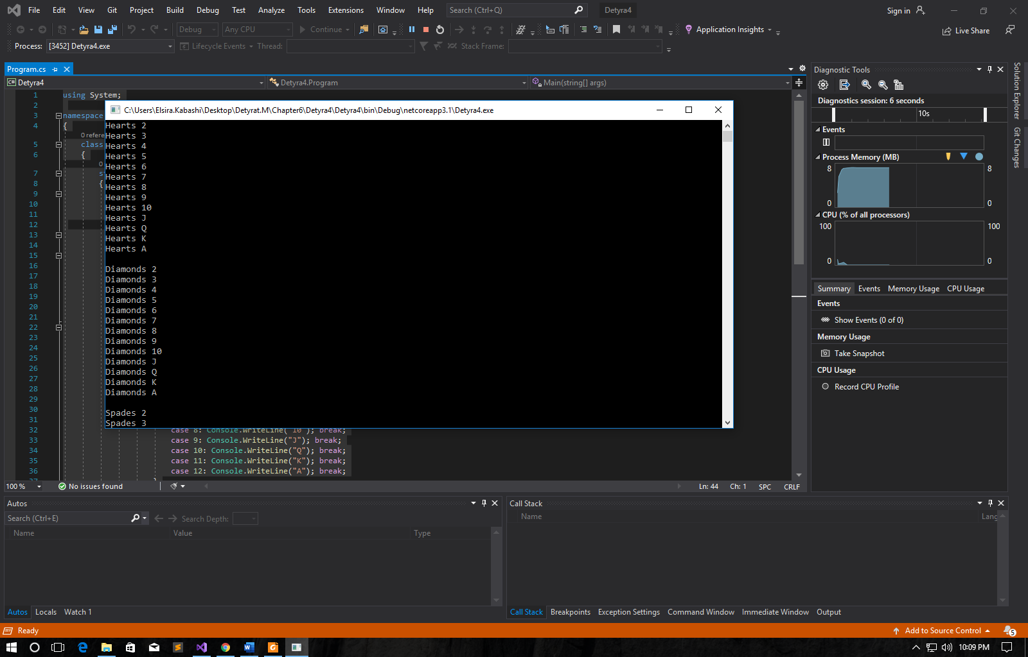 …………..

5. Write a program that reads from the console number N and print the sum  
of the first N members of the Fibonacci sequence: 0, 1, 1, 2, 3, 5, 8,  
13, 21, 34, 55, 89, 144, 233, 377, …

using System;

namespace Detyra5

{

class Program

{

static void Main(string[] args)

{

int firstN = 0, secondN = 1, thirdN = 2;

Console.Write("Enter N: ");

int length = Int32.Parse(Console.ReadLine());

Console.Write("0, 1,");

for (int i = 2; i < length; i++)

{

thirdN = firstN + secondN;

Console.Write(" {0},", thirdN);

firstN = secondN;

secondN = thirdN;

}

}

}

}

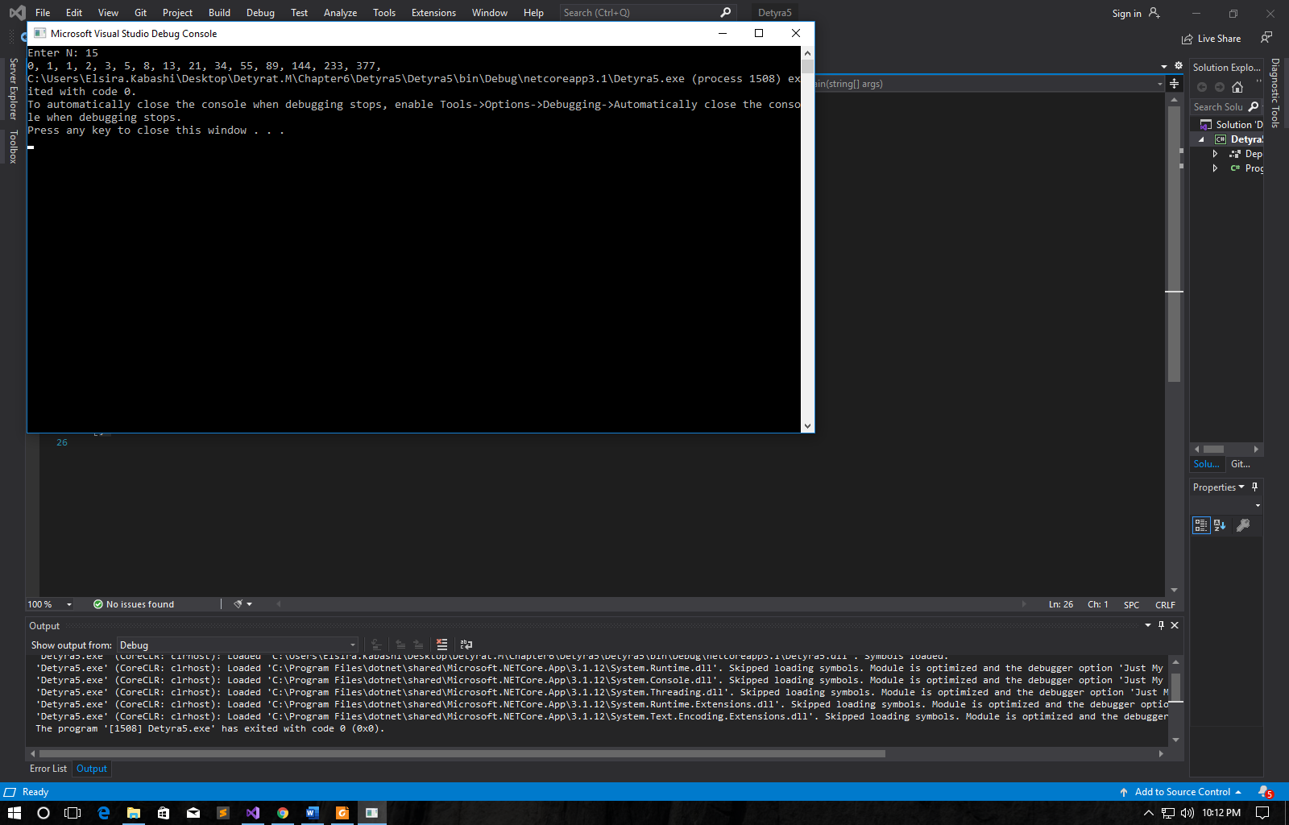

6. Write a program that calculates N!/K! for given N and K (1<K<N)

using System;

namespace Detyra6

{

class Program

{

static void Main(string[] args)

{

Console.Write("Enter N: (1<K<N) ");

int n = Int32.Parse(Console.ReadLine());

Console.Write("Enter K: (1<K<N) ");

int k = Int32.Parse(Console.ReadLine());

for (int i = n - 1; i > 0; i--)

{

n *= i;

}

for (int i = k - 1; i > 0; i--)

{

k *= i;

}

n /= k;

Console.WriteLine("Result is {0}", n);

}

}

}

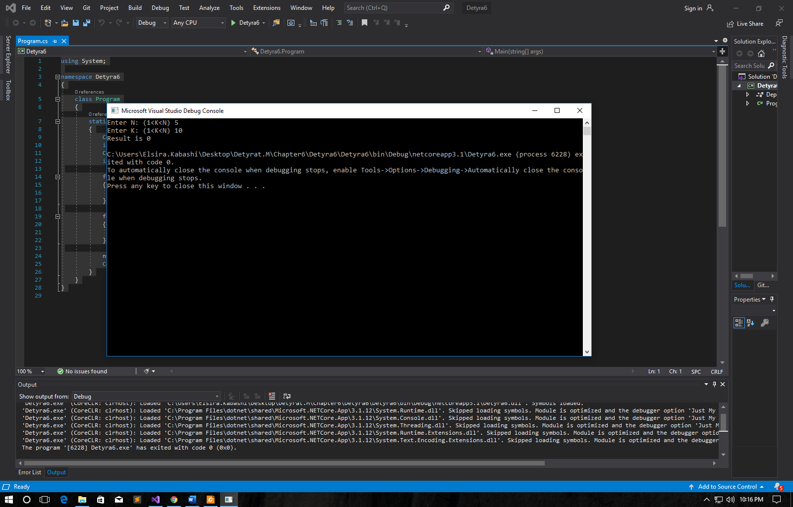

7. Write a program that calculates N!*K!/(N-K)! for given N and K  
(1<K<N).

using System;

namespace Detyra7

{

class Program

{

static void Main(string[] args)

{

Console.Write("Enter N: (1<K<N) ");

int n = Int32.Parse(Console.ReadLine());

Console.Write("Enter K: (1<K<N) ");

int k = Int32.Parse(Console.ReadLine());

int nMinusK = n - k;

for (int i = n - 1; i > 0; i--) n *= i;

for (int i = k - 1; i > 0; i--) k *= i;

for (int i = nMinusK - 1; i > 0; i--) nMinusK *= i;

Console.WriteLine("Result is {0}", n * k / nMinusK);

}

}

}

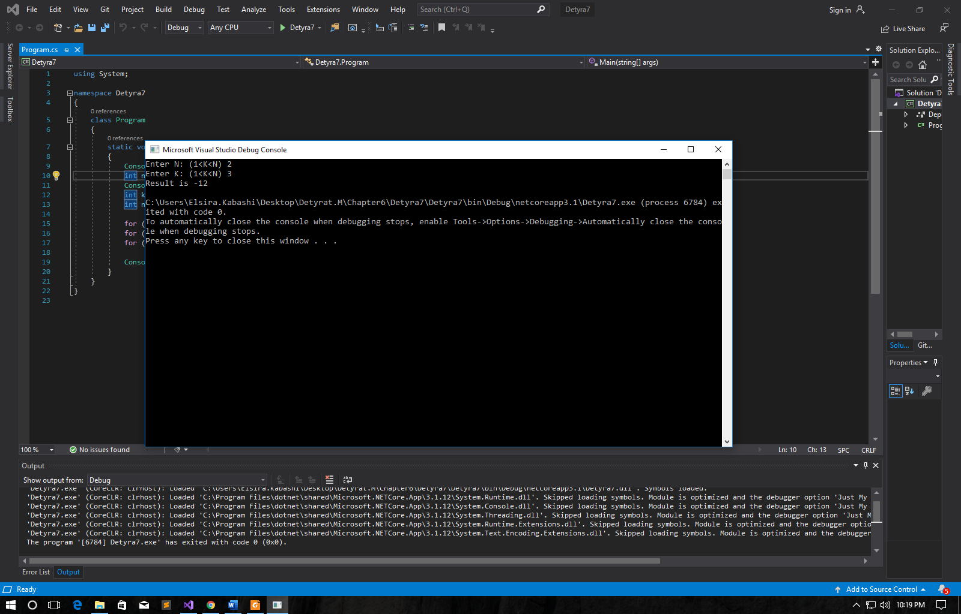

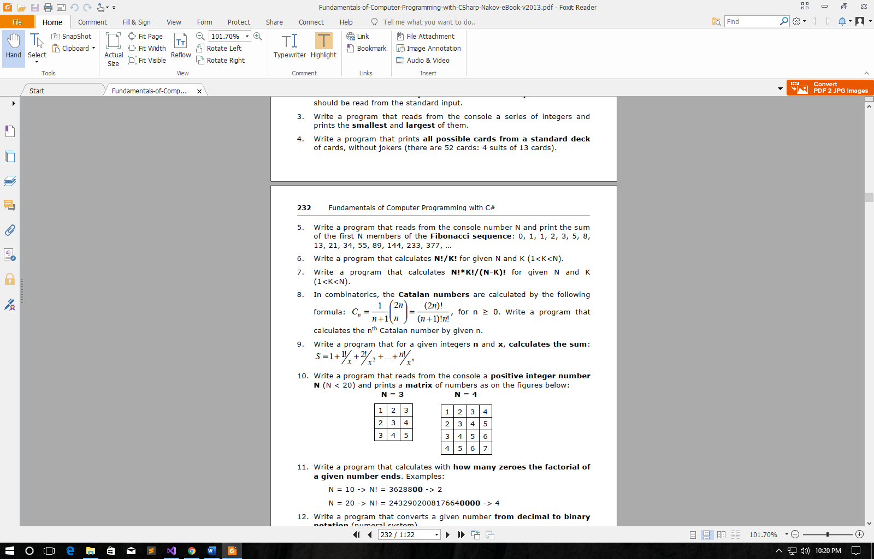

using System;

namespace Detyra8

{

class Program

{

static void Main(string[] args)

{

Console.Write("Enter N: (N >=0 ) ");

int n = Int32.Parse(Console.ReadLine());

int fact2N = 2 * n, factNplus1 = n + 1;

for (int i = fact2N - 1; i > 0; i--) fact2N *= i;

for (int i = factNplus1 - 1; i > 0; i--) factNplus1 *= i;

for (int i = n - 1; i > 0; i--) n *= i;

Console.WriteLine("Result is {0}", fact2N / (factNplus1 * n));

}

}

}

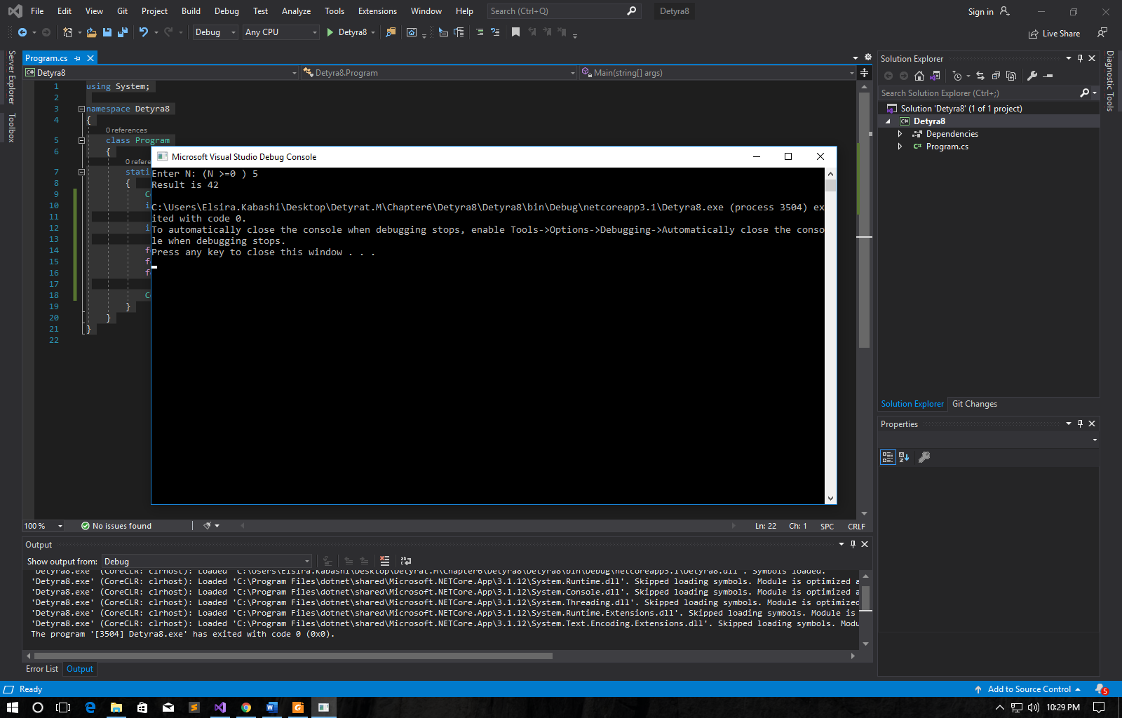

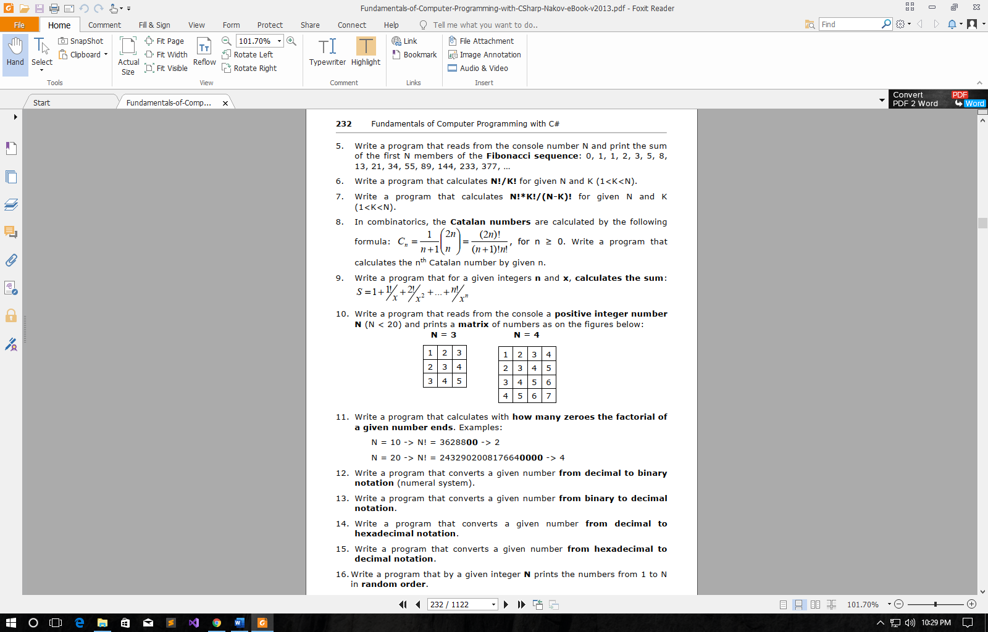

using System;

namespace Detyra9

{

class Program

{

static void Main(string[] args)

{

int sum = 1, temp = 1;

Console.Write("Enter n: ");

int n = Int32.Parse(Console.ReadLine());

Console.Write("Enter x: ");

int x = Int32.Parse(Console.ReadLine());

for (int i = 1; i <= n; i++)

{

temp *= i / x;

sum += temp;

}

Console.WriteLine("Result is {0}", sum);

}

}

}

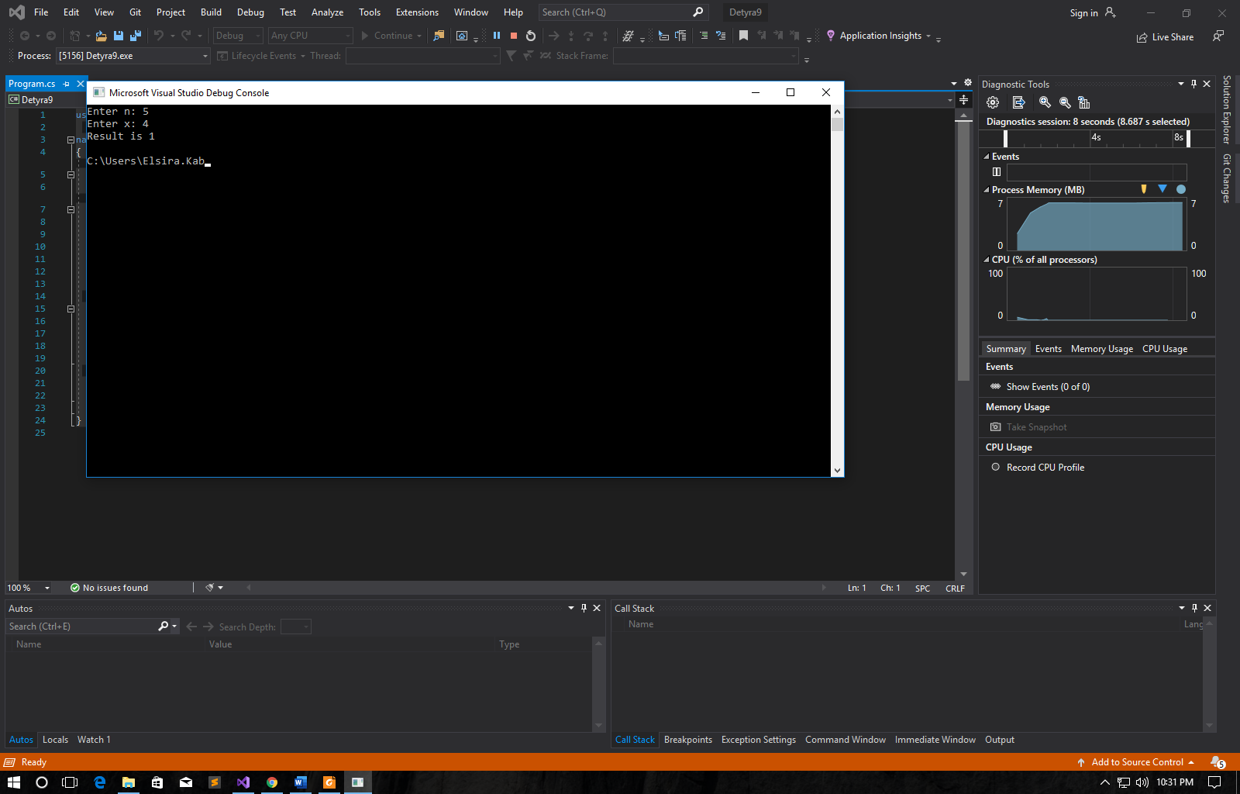

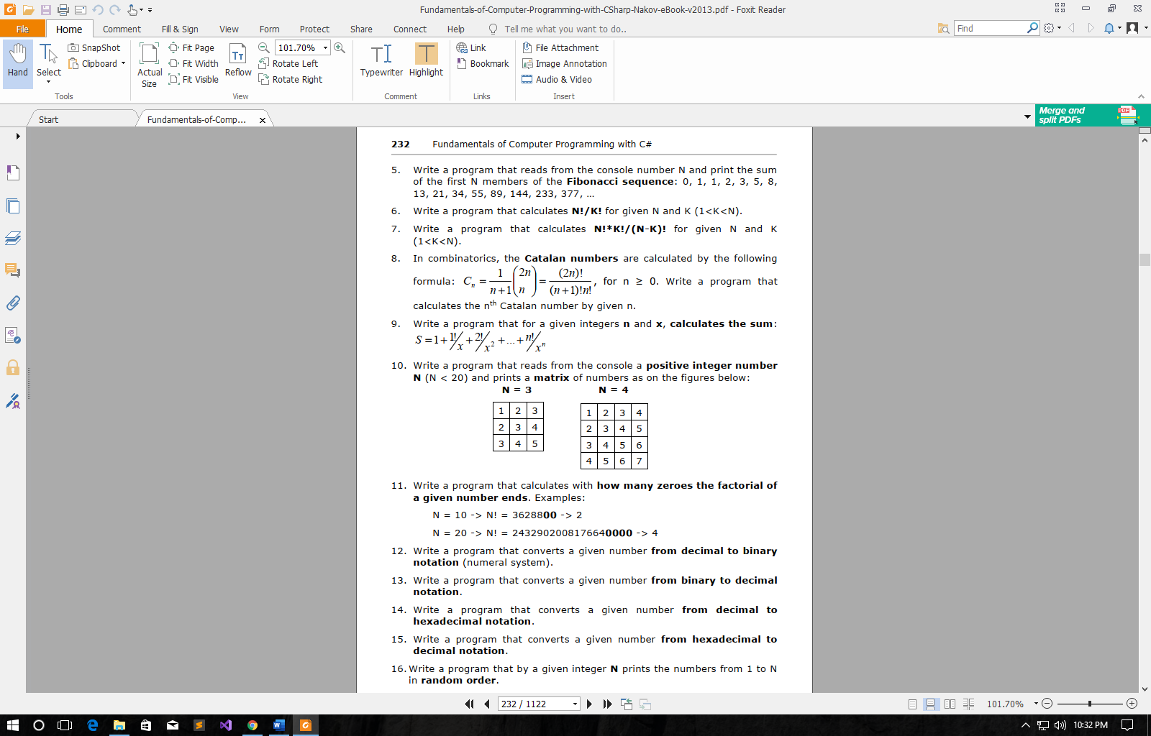

using System;

namespace Detyra10

{

class Program

{

static void Main(string[] args)

{

Console.Write("Enter N: (N < 20) ");

int n = Int32.Parse(Console.ReadLine());

for (int i = 1; i <= n; i++)

{

for (int j = i; j <= i; j++)

{

Console.Write("{0} ", j);

}

Console.WriteLine();

}

}

}

}

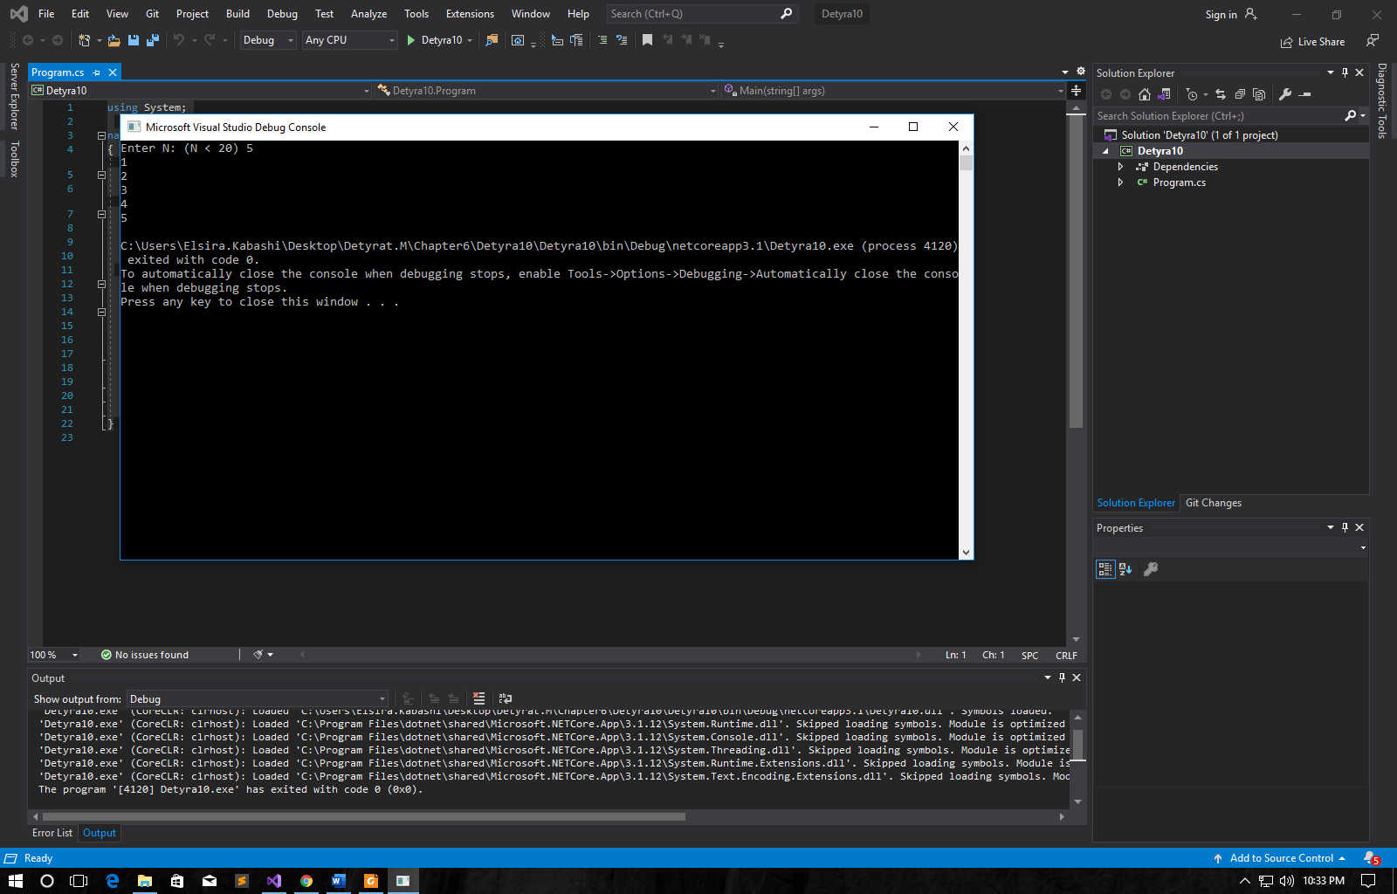

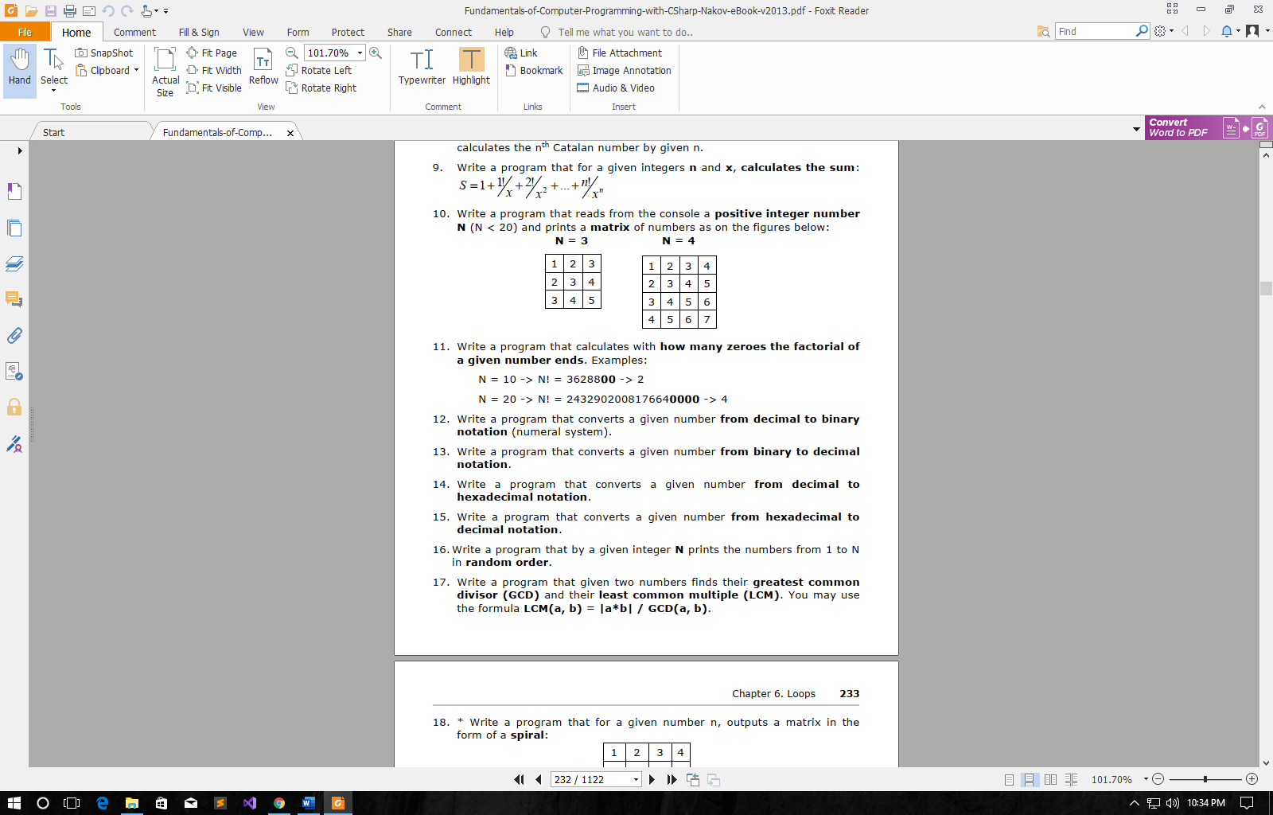

using System;

namespace Detyra11

{

class Program

{

static void Main(string[] args)

{

Console.Write("Enter N: ");

decimal n = Int32.Parse(Console.ReadLine());

int zeroes = 0;

for (int i = (int)(n - 1); i > 0; i--)

n *= i;

Console.Write("N! is {0} and it ends ", n);

do

{

n /= 10;

zeroes++;

} while (n % 10 == 0);

Console.WriteLine("with {0} zeroes.", zeroes);

}

}

}

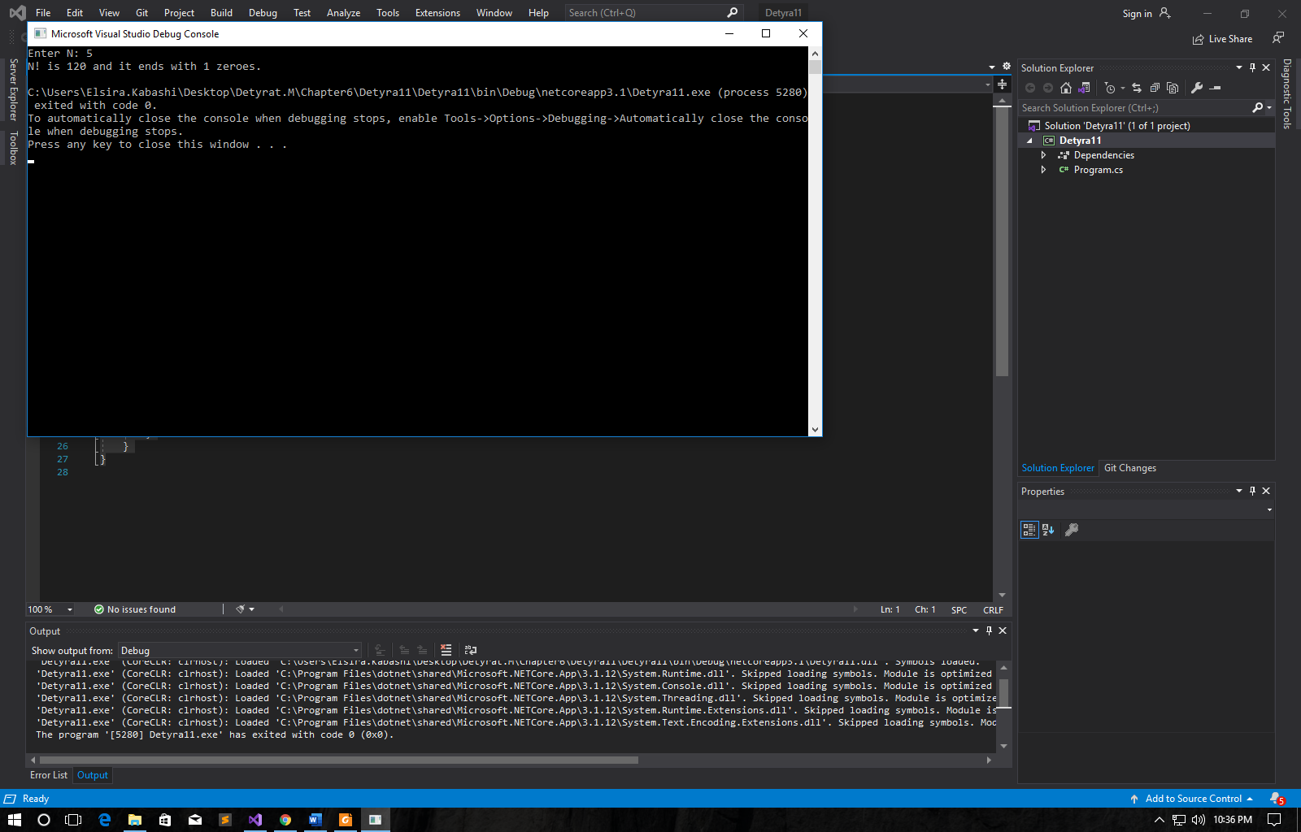

12. Write a program that converts a given number from decimal to binarynotation (numeral system).

using System;

namespace Detyra12

{

class Program

{

static void Main(string[] args)

{

Console.WriteLine("Input number to get binary equivalent");

Console.WriteLine("Binary equivalent of your number: " + Convert.ToString(Convert.ToInt32(Console.ReadLine()), 2));

}

}

}

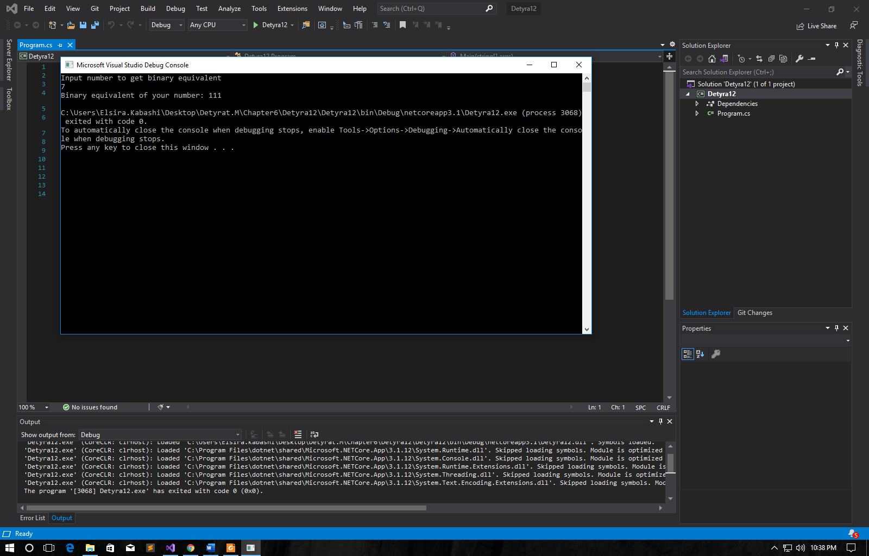

13. Write a program that converts a given number from binary to decimalnotation.

using System;

namespace Detyra13

{

class Program

{

static void Main(string[] args)

{

int num, binary_val, decimal_val = 0, base_val = 1, rem;

Console.Write("Enter a Binary Number(1s and 0s) : ");

num = int.Parse(Console.ReadLine()); /* maximum five digits */

binary_val = num;

while (num > 0)

{

rem = num % 10;

decimal_val = decimal_val + rem * base_val;

num = num / 10;

base_val = base_val * 2;

}

Console.Write("The Binary Number is : " + binary_val);

Console.Write("\nIts Decimal Equivalent is : " + decimal_val);

Console.ReadLine();

}

}

}

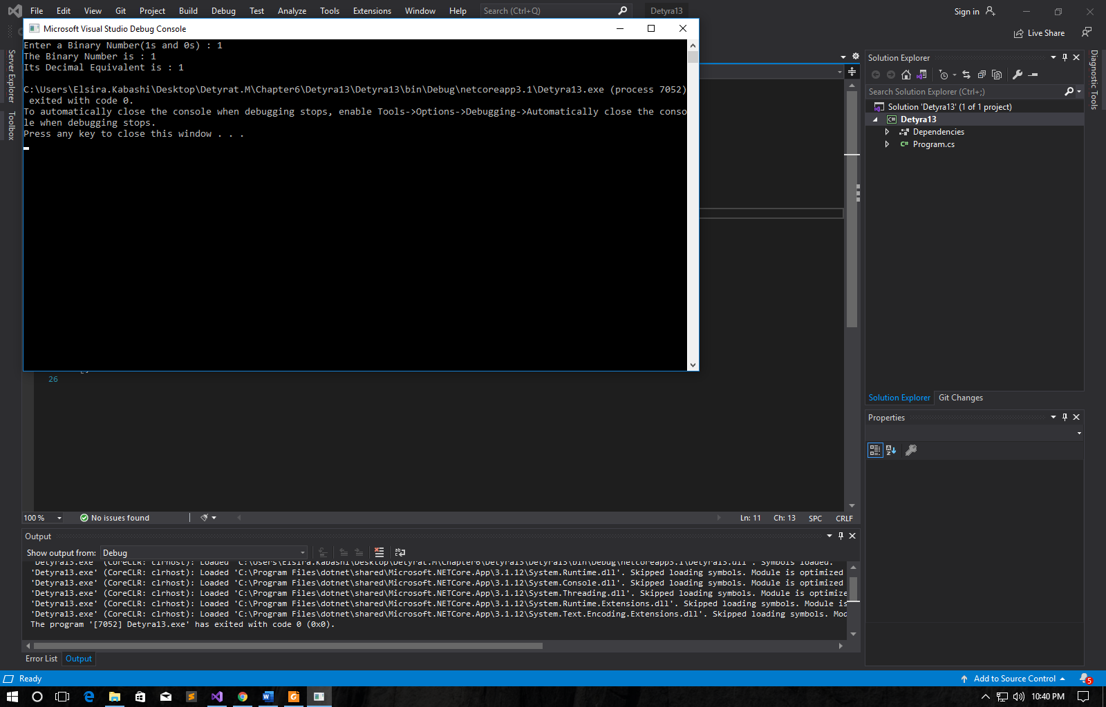

14. Write a program that converts a given number from decimal tohexadecimal notation.

using System;

namespace Detyra14

{

class Program

{

static void Main(string[] args)

{

int x;

string hexvalue;

Console.WriteLine("Input any decimal number: ");

x = Convert.ToInt32(Console.ReadLine());

hexvalue = x.ToString("X");

Console.WriteLine("The equivalent hexadecimal number: {0}", hexvalue);

}

}

}

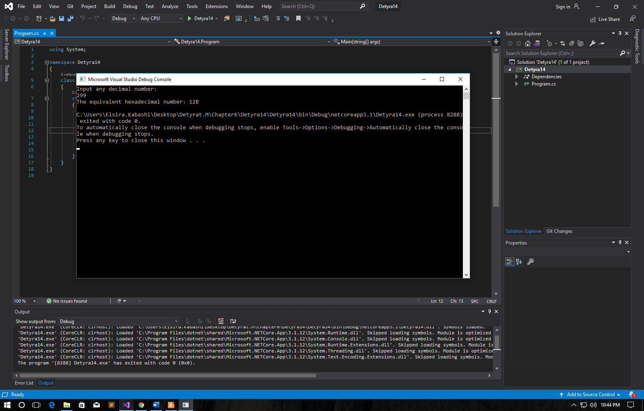

15. Write a program that converts a given number from hexadecimal todecimal notation.

using System;

namespace Detyra15

{

class Program

{

static void Main(string[] args)

{

string hexval = "4B0";

Console.WriteLine("Hexadecimal number: " + hexval);

int decValue = int.Parse(hexval, System.Globalization.NumberStyles.HexNumber);

Console.WriteLine("Convert to-");

Console.WriteLine("Decimal number: " + decValue);

}

}

}

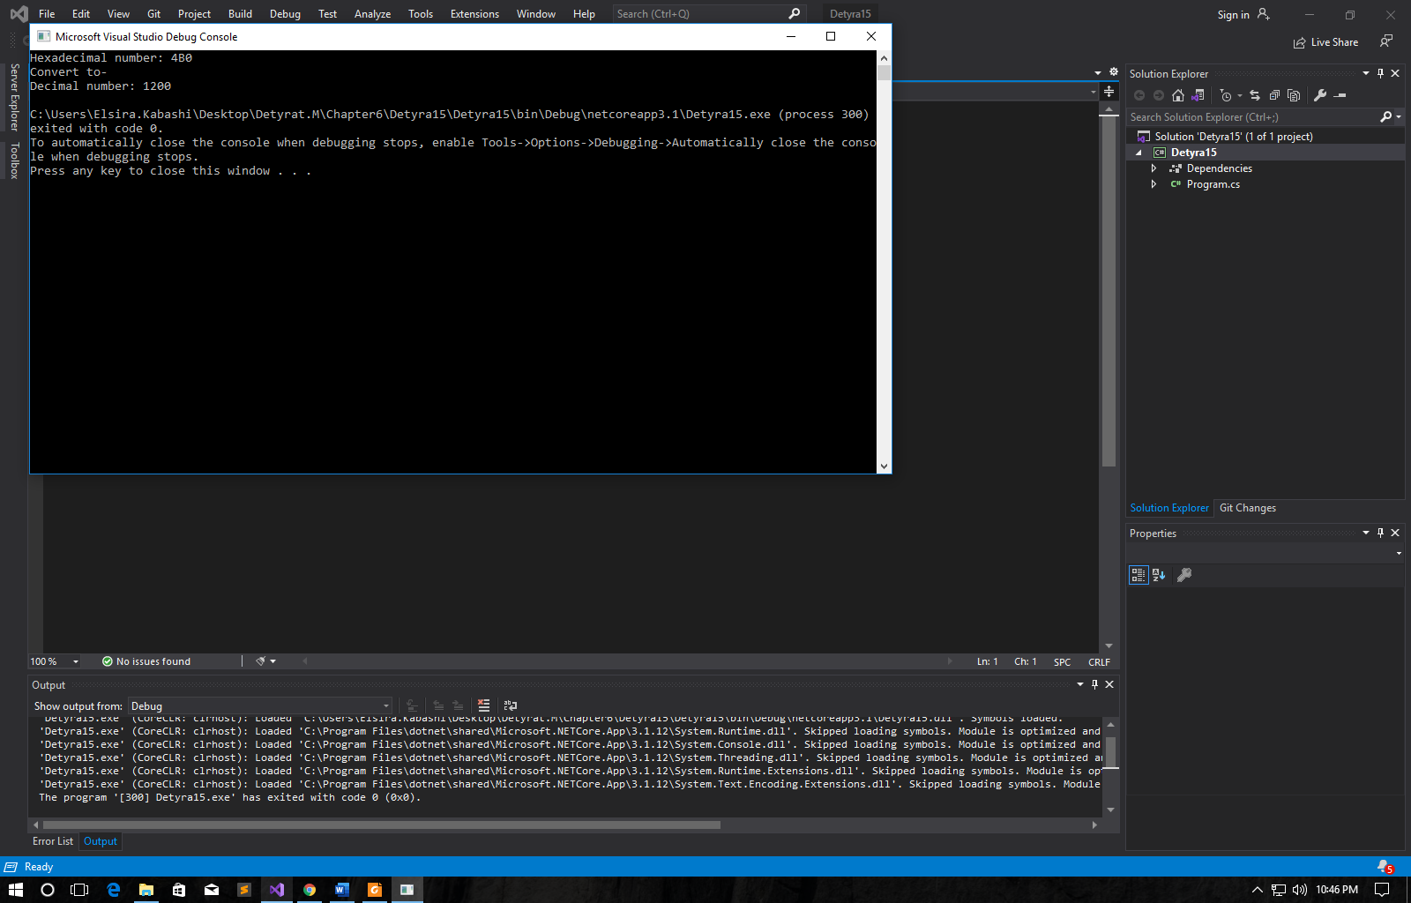

16.Write a program that by a given integer N prints the numbers from 1 to N  
in random order.

using System;

namespace Detyra16

{

class Program

{

static void Main(string[] args)

{

Random rnd = new Random();

int temp, randomNumber;

Console.Write("Enter number: ");

int n = Int32.Parse(Console.ReadLine());

int[] arr = new int[n];

for (int i = 0; i < arr.Length; i++)

{

arr[i] = i;

}

foreach (int i in arr)

{

randomNumber = rnd.Next(0, n);

temp = arr[i];

arr[i] = arr[randomNumber];

arr[randomNumber] = temp;

}

foreach (int i in arr) Console.WriteLine(arr[i]);

}

}

}

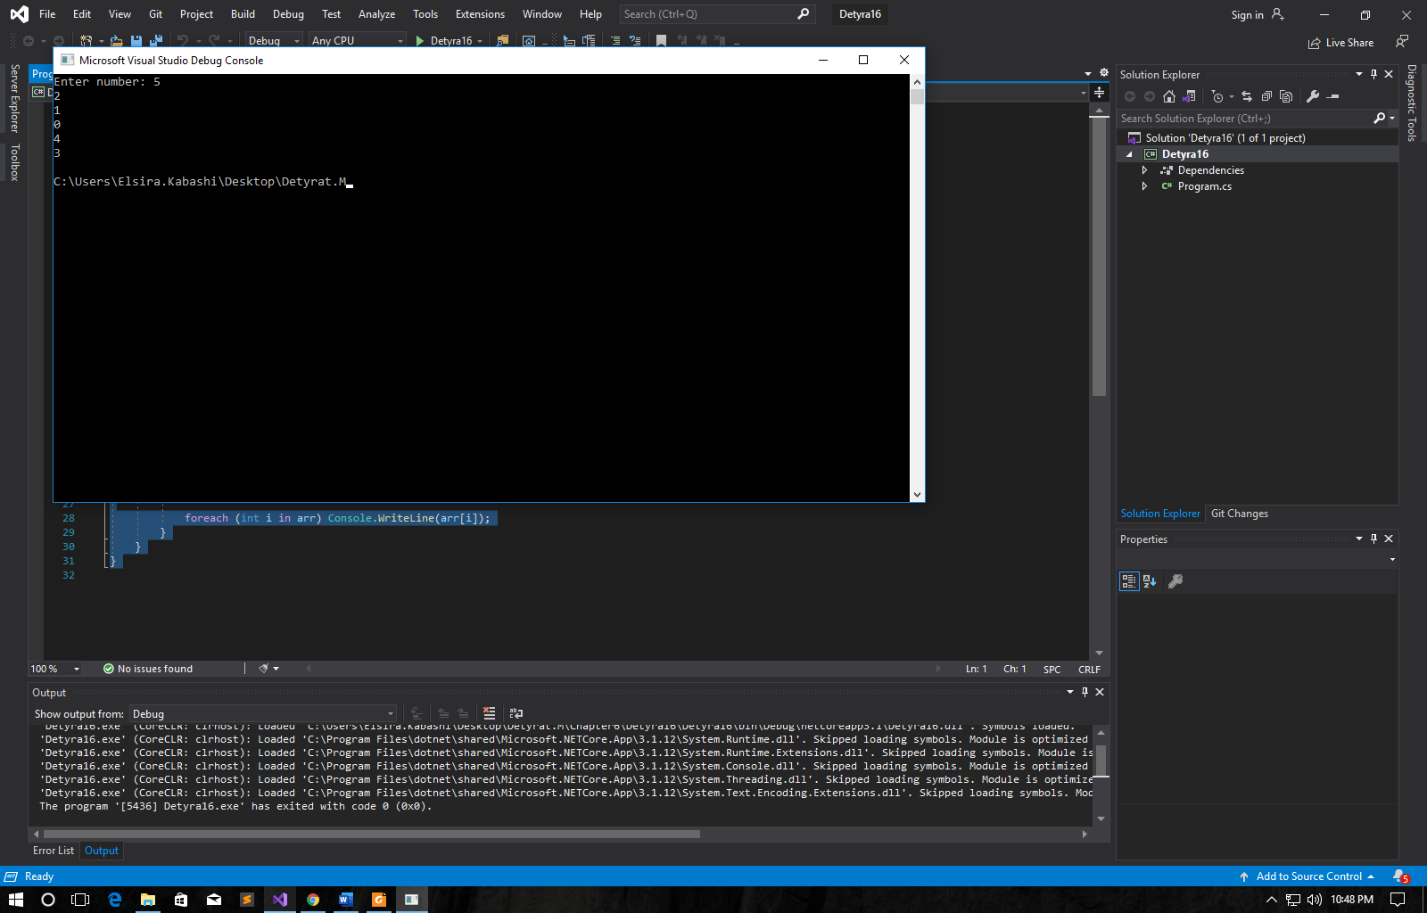

17. Write a program that given two numbers finds their greatest commondivisor (GCD) and their least common multiple (LCM). You may use  
the formula LCM(a, b) = |a*b| / GCD(a, b).

using System;

namespace Detyra17

{

class Program

{

static void Main(string[] args)

{

Console.Write("Enter first number: ");

int a = Int32.Parse(Console.ReadLine());

Console.Write("Enter second number: ");

int b = Int32.Parse(Console.ReadLine());

while (a != 0 && b != 0)

{

if (a > b) a %= b;

else b %= a;

}

if (a == 0) Console.WriteLine(b);

else Console.WriteLine(a);

}

}

}

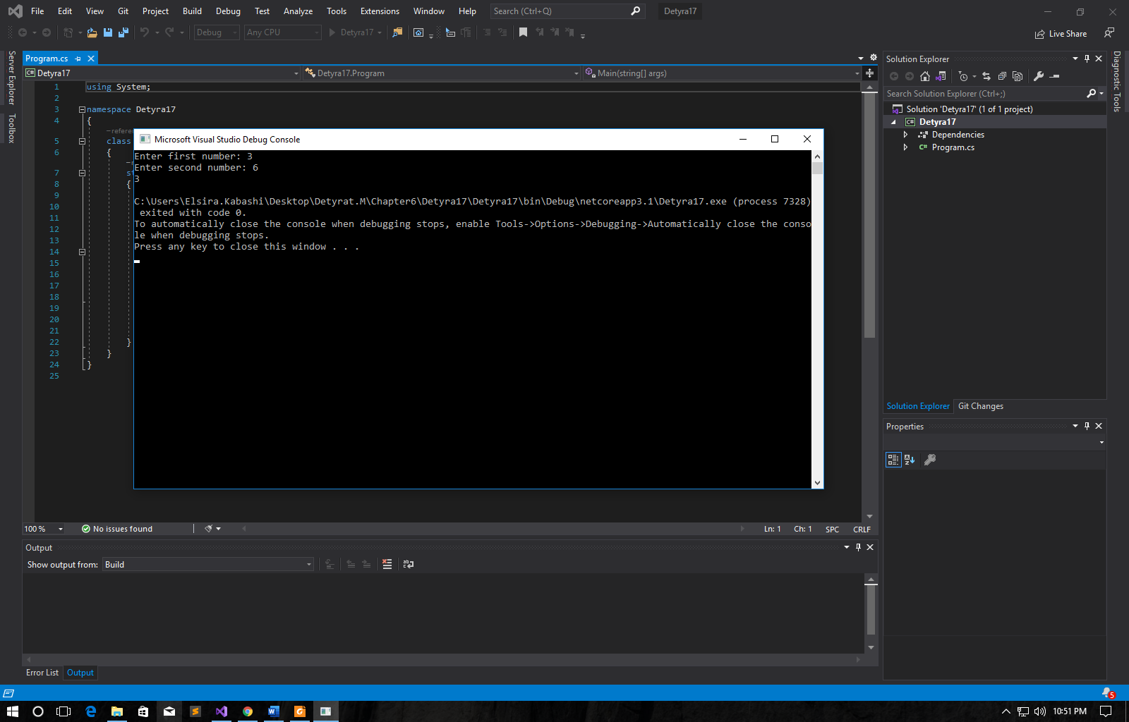

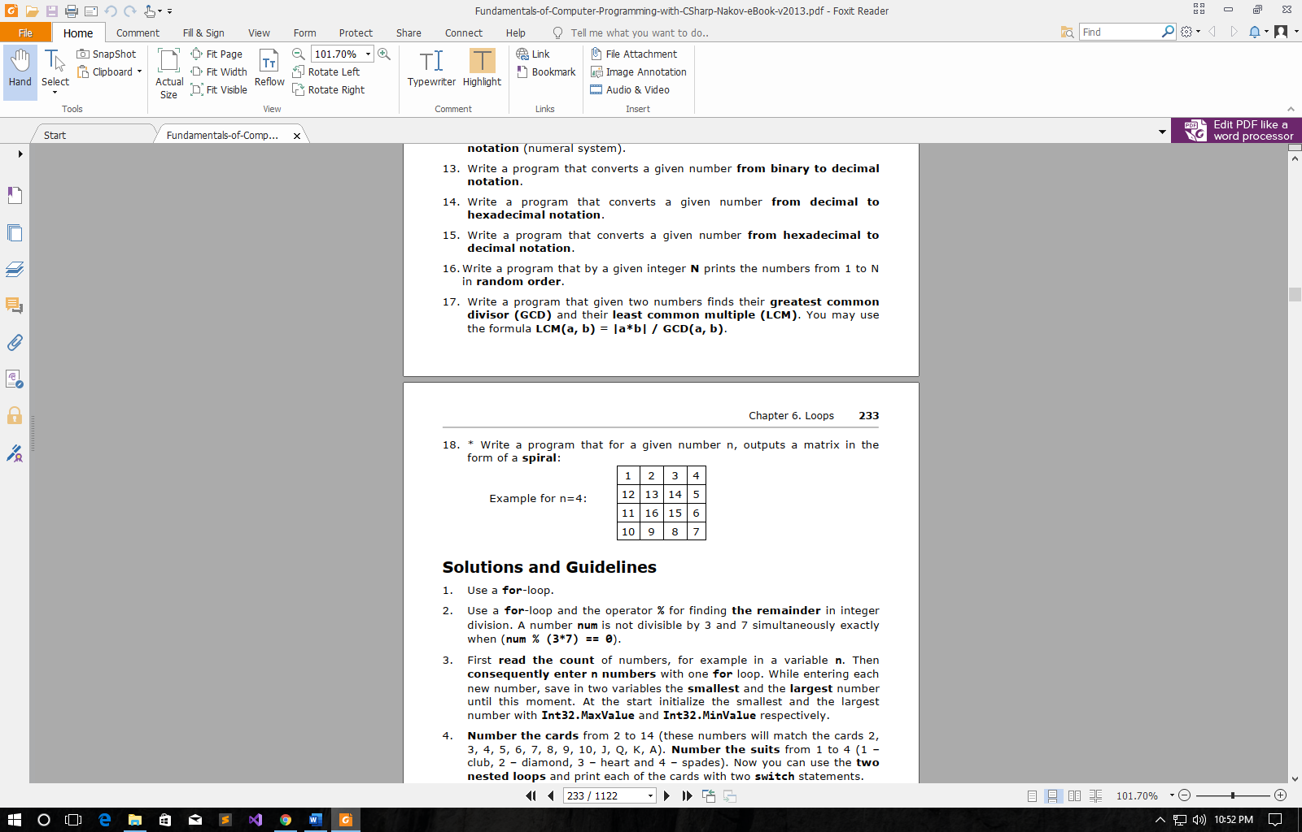

using System;

namespace Detyra18

{

class Program

{

static void Main(string[] args)

{

Console.Write("Enter N: ");

int n = Int32.Parse(Console.ReadLine());

int[,] matrix = new int[n, n];

int row = 0, col = 0, direction = 0;

for (int i = 1; i <= n * n; i++)

{

switch (direction)

{

case 0:

if (col > n - 1 || matrix[row, col] != 0)

{

direction = 1;

col--;

row++;

}

break;

case 1:

if (row > n - 1 || matrix[row, col] != 0)

{

direction = 2;

row--;

col--;

}

break;

case 2:

if (col < 0 || matrix[row, col] != 0)

{

direction = 3;

col++;

row--;

}

break;

case 3:

if (row < 0 || matrix[row, col] != 0)

{

direction = 0;

row++;

col++;

}

break;

}

matrix[row, col] = i;

switch (direction)

{

case 0: col++; break;

case 1: row++; break;

case 2: col--; break;

case 3: row--; break;

}

}

for (int i = 0; i < n; i++)

{

for (int j = 0; j < n; j++)

{

if (matrix[i, j] < 10) Console.Write("{0} ", matrix[i, j]);

else Console.Write("{0} ", matrix[i, j]);

}

Console.WriteLine();

}

}

}

}

 